**Week 6 Lab: Creating a SOAP Client Using Spring Boot**

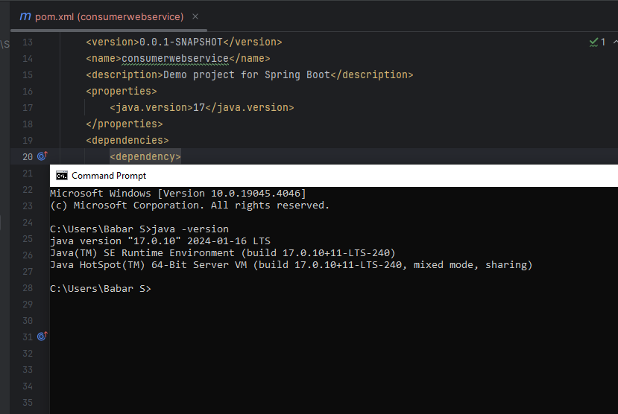

Figure : Java version in pom.xml and cmd

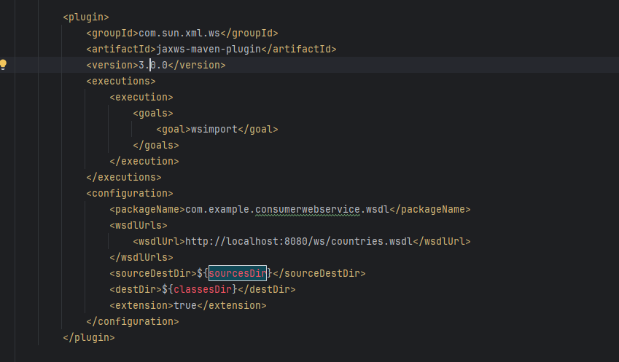

Figure : wsdl plugin in pom.xml

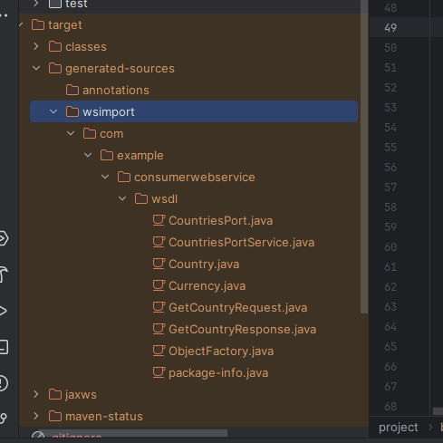

Figure : Services end points